Facade design pattern

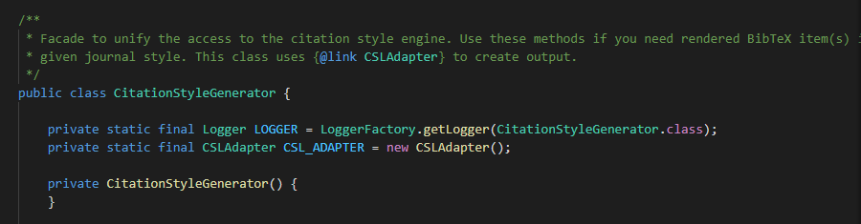

This class can be found in: src\main\java\org\jabref\logic\citationstyle\CitationStyleGenerator.java.

It is used to unify the access to the citation style engine.

